Control group training for iTrain

The basic idea is that we want to create a placebo control version of the training that removes the memory component from the three WM tasks (category, decision, and sentence), but is still adaptive, goal driven, and engaging enough that participants continue with the training.

What I would like to do is to refocus the three tasks towards training decision speed, instead of training working memory. So, first, we can get rid of the memory component for each of the three tasks, so that participants are only making speeded Yes/No judgments (e.g., plausible or implausible sentence, word or non-word, category or non-category).

The following additional changes should be made:

-We should increase the trial size to 20 per block, and keep this fixed (this is in contrast to the memory tasks that begin with a trial size of 2 and increase as participants’ memory span improves). In these blocks, participants have to maintain an average accuracy level of 85% (17 out of 20 correct judgments— this room for error should hopefully accommodate the rare cases in the category task where individuals get shown a word from a “non-category” list that actually would fit with the superordinate category).

When a participant’s accuracy for a block is 85% or higher, then the presentation rate for the next block should decrease by some percentage that we can control in the Admin Interface (default value something like 5%... see figures attached below). This way, we can use the same staircase training method as we do with the WM training, just replacing memory span with presentation rate. Presentation rates should decrease continually until the participants’ accuracy falls below the 85% accuracy threshold, at which point they will move back up to the presentation rate at which they last scored at or above 85% accuracy.

Presentation rates for the first trial can be pre-set by the experimenter (same as with Sentence Span, Category Span, and LD Span). We can start with the same presentation rates that are used for the WM training group right now:

Category Presentation Time: **4000**; Decision Word Time: **4000** ;Sentence Presentation Time: **15000**

We can set up the “Records.csv” output file using the same format as the WM training file. That is, subject number, task, session, date, “Speed level”, judgment accuracy, and average RT. Everything else we can keep the same.

When a participant answers, the item should disappear for the rest of the duration of the trial, before moving on. For example, if they are just starting out on the word decision task and the block is set at 4 seconds, and they answer within the first second, then the item should disappear for the rest of the trial (3 seconds), before moving onto the next trial. Trial progression should be fixed by the “Speed Level” that they are currently on.

I’ve included some instructions for each of the tasks on the last page:

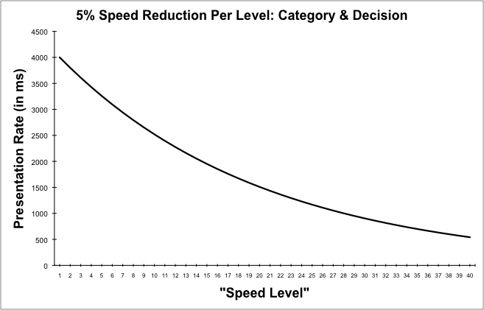

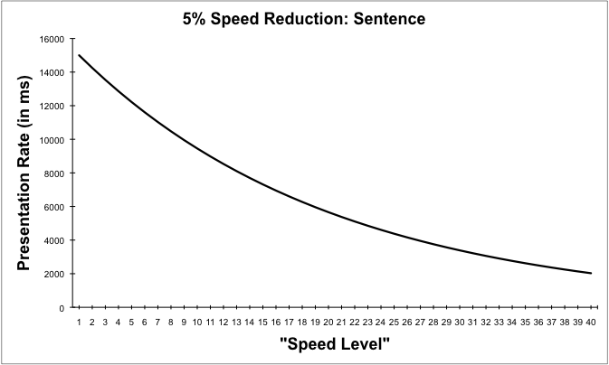

**Category Instructions:**

In this game, a series of single words will appear on the screen one at a time, along with a particular category.

You will decide if the word belongs to the given category or not. If the word belongs to the category, you should press the YES button (on the left hand side of the screen). If the word does not belong to the category, you should press the NO button (on the right hand side of the screen). Be sure to read each word and make your judgment quickly.

Be sure to read each word and make your judgment as quickly as possible. As you progress through the game, the speed with which the words are presented will increase. Your job is to maintain as of high of a level of accuracy as possible while making your decisions as fast as possible.

At the end of each set of 20 trials, you will be given feedback about your performance before beginning the next set of trials.

**Decision Instructions:**

In this game, a series of single words (e.g., seek) and non-words (e.g., ceek) will appear on the screen, one at a time.

You will decide if the string of letters forms a word or not, by pressing YES (on the left hand side of the screen) if the string of letters does form a word and NO (on the right hand side of the screen) if the string of letters does not form a word.

Be sure to read each word and make your judgment as quickly as possible. As you progress through the game, the speed with which the words are presented will increase. Your job is to maintain as high of a level of accuracy as possible while making your decisions as fast as possible.

At the end of each set of 20 trials, you will be given feedback about your performance before beginning the next set of trials.

**Sentence Instructions**

In this game, a series of simple sentences will appear on the screen one at a time.

You will read each sentence to yourself. After you are done reading, decide whether the sentence is acceptable, by pressing the YES button (on the left hand side of the screen) or unacceptable, by pressing the NO button (on the right hand side of the screen). Please don't make this judgment based on the truth of the sentence, but rather judge whether the sentence is a plausible and acceptable sentence in English.

For example, an acceptable sentence would be:

Development of the screenplay was done by a team of three authors.

An example of an unacceptable sentence is:

A laptop excited in utter and favorite day is confusing a melt.

Be sure to read each sentence and make your judgment as quickly as possible. As you progress through the game, the speed with which the sentences are presented will increase. Your job is to maintain as high of a level of accuracy as possible while making your decisions as fast as possible.

At the end of each set of 20 trials, you will be given feedback about your performance before beginning the next set of trials.